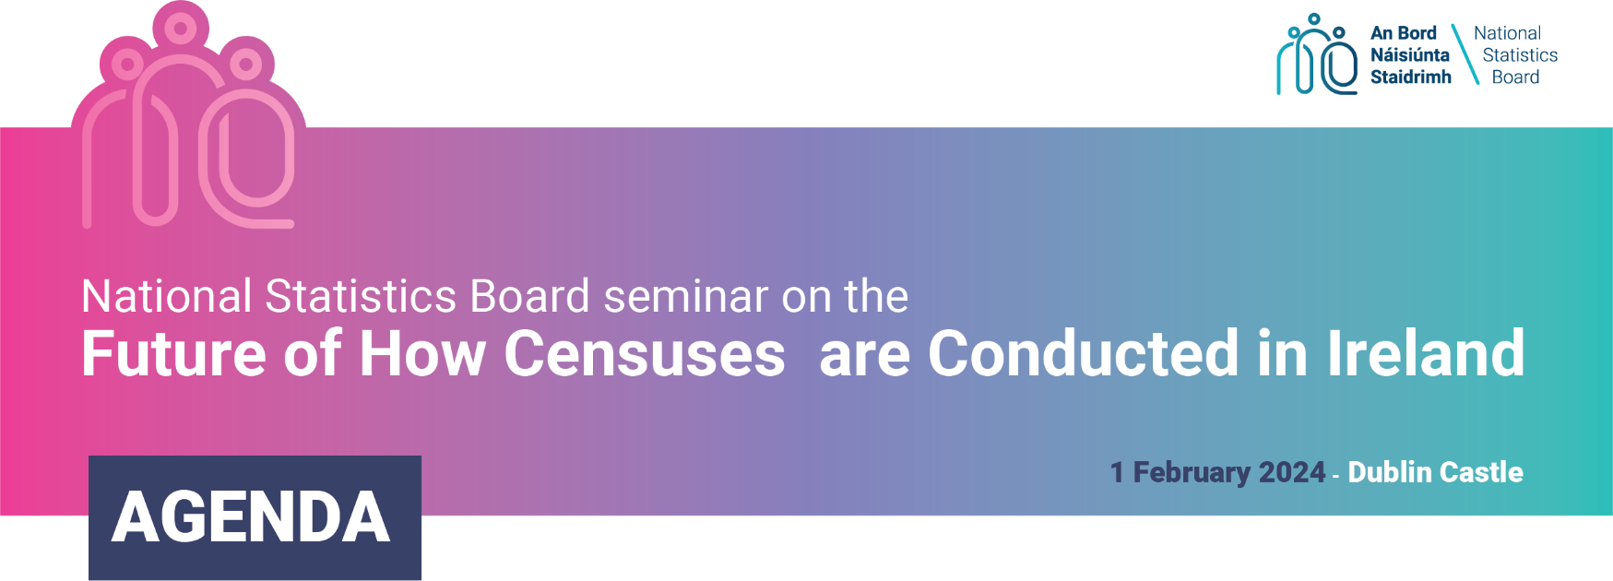
DATE: Thursday, 1st February 2024 - 9.15am to 1.30pm
VENUE: Hibernia Conference Centre, Dublin Castle
Registration 8.30 - 9.15
Introduction and Welcome: 9.15 - 9.45
Minister Hildegarde Naughton, TD
Anne Vaughan - Chairperson of the National Statistics Board

Session 1: Census Taking in Ireland 9.45 - 11.00
The Census of Ireland in 2022 and 2027
Cormac Halpin, Senior Statistician, CSO
Options for the Future of how Censuses are Conducted in Ireland
Tim Linehan, Senior Statistician, CSO & Richard McMahon, Assistant Director General,
Social & Demographic Statistics, CSO
Q&A: 20 Minutes

Tea & Coffee 11.00 - 11.20

Session 2: 11.20 - 12.15
The future of population and migration statistics in England and Wales
Jennet Woolford, Director of Population Statistics at the Office for National Statistics (ONS), UK
Q&A: 15 minutes

Session 3: Panel Commentary & Open Forum 12.15 - 13.30
Panellists:
Helen Russell, Research Professor at the Economic and Social Research Institute
Martin Quigley, Director of Data and Analytics at Pobal
Catriona Crowe, Archivist and Broadcaster
Q&A: 40 mins
Concluding Remarks

